A picture containing clipart

Description generated with very high confidence

NodeJS Module 7

Hands-on 3

[**support@intellipaat.com**](mailto:support@intellipaat.com)

**+91-7022374614**

**US: 1-800-216-8930 (Toll Free)**

**NodeJS Module 7**

**Hands-on 3**

**Using Mongo Native Driver**

**Step 1**: Create a file named index.js

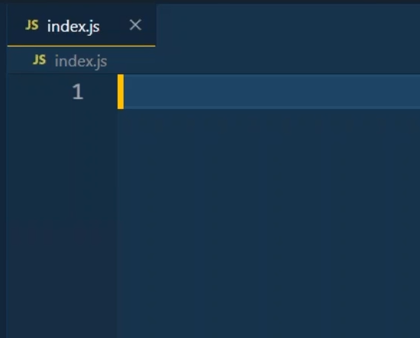

**Step 2**: Open a command prompt in the folder where you have created index,js file and run the command npm init --y

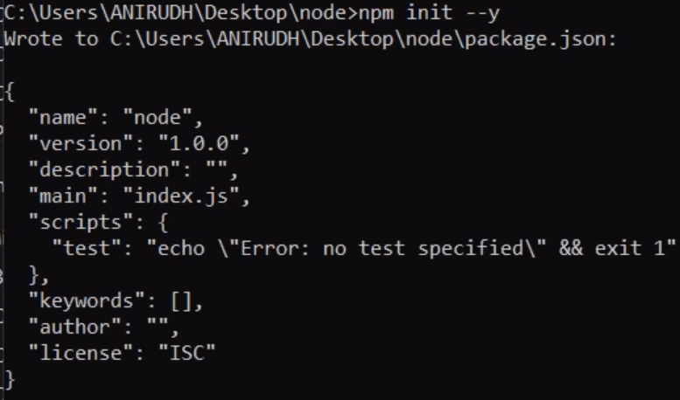

**Step 3**: Install MongoDB driver typing the command in the same prompt npm install mongodb

–save

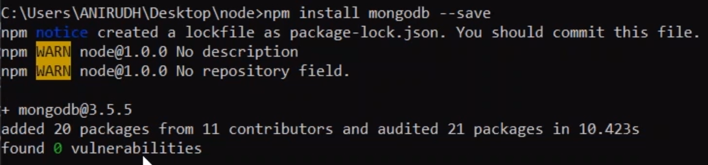

**Step 4**: Write the following code in index.js

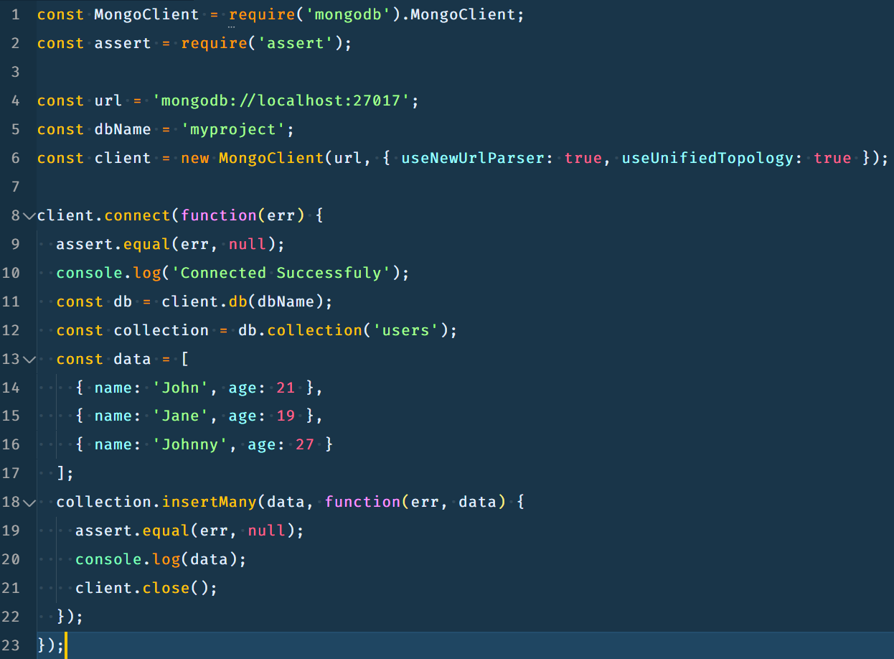

**Step 5**: In the command prompt type node index.js and run the script

